Android Heart Disease Prediction App

- Background/ Problem Statement

As per the estimates of the World Health Organisation Heart Diseases claim nearly 17.9 million lives each year. Heart Diseases maybe of various types and typically tend to worsen as the age of an individual advances.
Irrespective of the type of heart disease afflicting an individual, the benefit of early detection is undeniable. Like most diseases, detecting heart diseases at an earlier stage makes treatment easier and dramatically improves the chance of survival for an individual
This Heart Disease Prediction Android App has been designed to help users with assessing their cardiovascular health.
Based on a number of factors such as the user’s age, gender, blood sugar, cholesterol levels, blood pressure, etc. this system generates a prediction about the disease that the user might be suffering from.
Moreover, apart from assessing their cardiovascular health, users can also find contact details of various doctors on this application. The user can search for doctors by filtering them based on their speciality.

- Working of the Project

Admin is the sole user who manages the training data and can actively change or update any values.
Admin is also the person who will manage the doctor & their clinic details, view users & view their feedbacks.
User on the other hand has to create an account to use the prediction services. User will have to enter 13 data to get a prediction which system
uses Random Forest algorithm to predict. User can also update their profile and change the password.
Random Forest Algorithm is written in Asp.net with C# and hosted.

- Advantages
  - User can analyse their cardiovascular health.
  - Users can find details of various doctors and sort them by speciality.

- System Description
The system comprises of 2 major modules with their sub-modules as follows:

Admin
Login- login with the account details
Manage Doctor - Add and manage Doctor & Clinic details
Manage Training - Add and manage the Training set which consist of the following fields to train
Disease name, Age in Year, Gender, Chest Pain Type, Fasting Blood Sugar, Resting Electrographic Results (Restecg), Exercise Induced Angina (Exang), The slope of the peak exercise ST segment, CA – Number of major vessels colored by fluoroscopy, Thal, trest Blood Pressure, Serum Cholesterol
View User - View user details
View Feedback - view all the feedback given by the users-

User
Register - create an account with basic details-
Login - login with the account details
Profile - view & update your profile
Change Password - user can change the password
Home - Analyze your Heart
The user will have to fill in the below 13 fields for the system to predict a disease
-Age in Year
-Gender
-Chest Pain Type
-Fasting Blood Sugar
-Resting Electrographic Results(Restecg)
-Exercise Induced Angina(Exang)
-The slope of the peak exercise ST segment
-CA – Number of major vessels colored by fluoroscopy
-Thal
-Trest Blood Pressure
-Serum Cholesterol
-Maximum heart rate achieved(Thalach)
-ST depression induced by exercise(Oldpeak)

View Doctors - view doctor detail by searching by names or filter by specialty
Feedback - send feedback to the Admin.

- Project Life Cycle

The waterfall model is a classical model used in system development life cycle to create a system with a linear and sequential approach. It is termed as waterfall because the model develops systematically from one phase to another in downward fashion. The waterfall approach does not define the process to go back to the previous phase to handle changes in requirement. The waterfall approach is the earliest approach that was used for software development

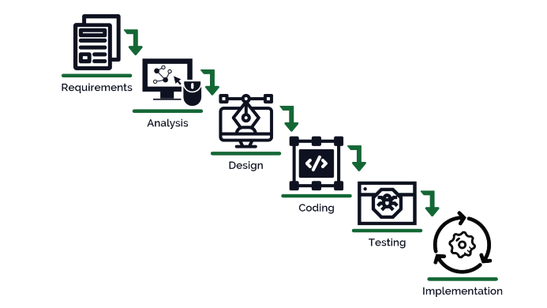

- System Requirement

- Hardware Requirement

- Laptop or PC
- I3 processor system or higher
- 4 GB RAM or higher
- 100 GB ROM or higher

- Android Phone (6.0 and above)

- Software Requirement

- Laptop or PC
- Windows 7 or higher
- Android Studio

- Limitation/Disadvantages

- Wrong inputs will affect the project outputs.
- Internet Connection is mandatory.
- Membership cannot be cancelled.

- Application – This system can be used to predict the presence of heart disease.

- Reference- https://ieeexplore.ieee.org/document/9619208/

